Musawakhe Andrew Nzama
SQL JOIN Practice Instructions

SQL JOIN Practice Questions
1. INNER JOIN: Orders with Customer and Product Names
Question: List all orders along with the customer name and product name.
Expected Output Columns:
- OrderID, OrderDate, CustomerName, ProductName, Quantity
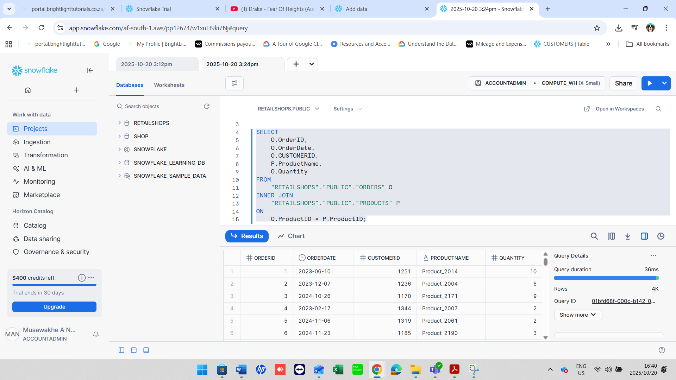

2. INNER JOIN: Customers Who Placed Orders
Question: Which customers have placed at least one order?
Expected Output Columns:
- CustomerID, CustomerName, Country, OrderID, OrderDate
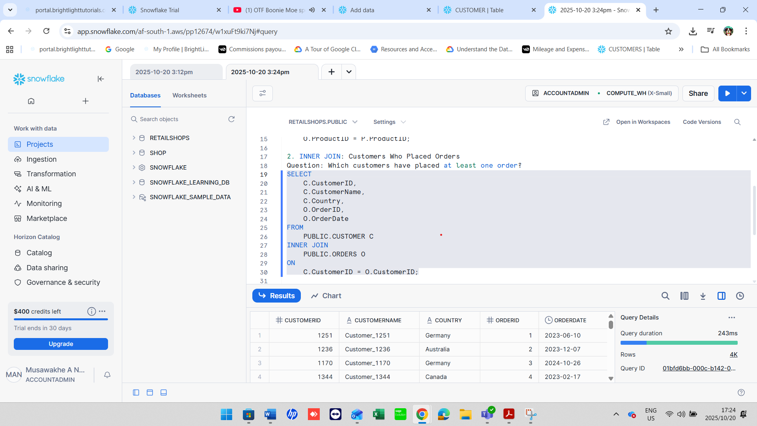

3. LEFT JOIN: All Customers and Their Orders
Question: List all customers and any orders they might have placed. Include customers who have not placed any orders.
Expected Output Columns:
- CustomerID, CustomerName, Country, OrderID, OrderDate, ProductID, Quantity
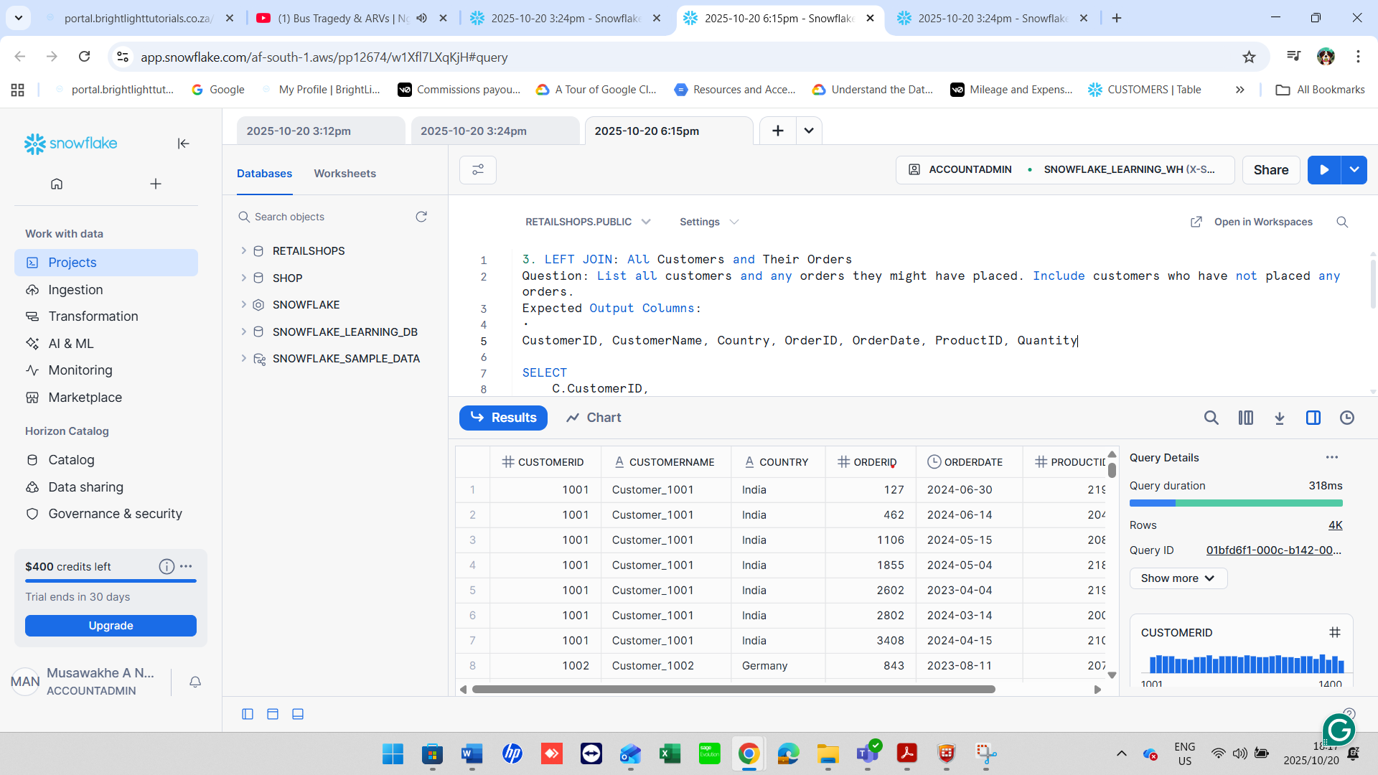

4. LEFT JOIN: Product Order Count
Question: List all products and how many times each was ordered (if any).
Expected Output Columns:
- ProductID, ProductName, TotalOrders (TotalOrders is the count of how many times the product appears in orders)

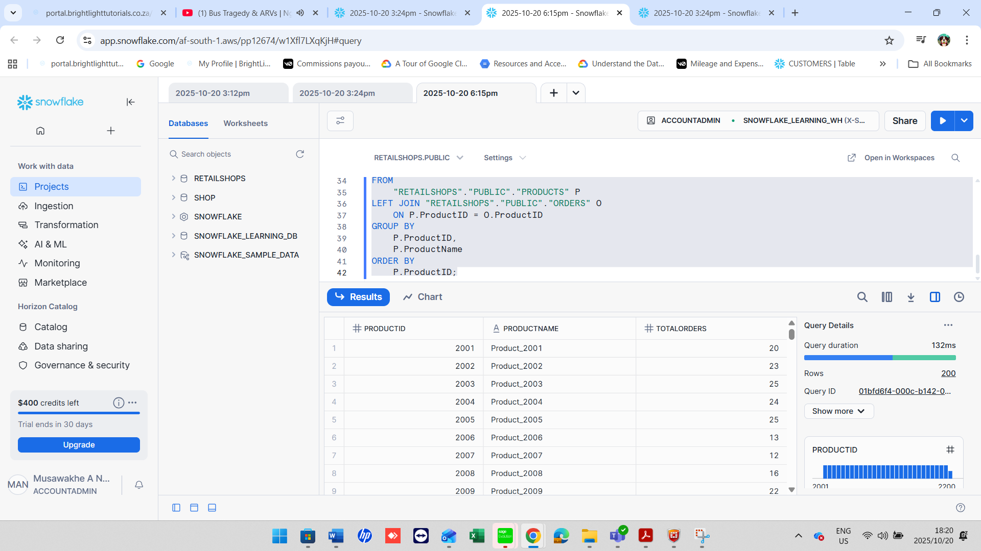

5. RIGHT JOIN: Orders with Product Info (Include Products Not Ordered)
Question: Find all orders along with product details, including any products that might not have been ordered.
Expected Output Columns:
- OrderID, OrderDate, ProductID, ProductName, Price, Quantity
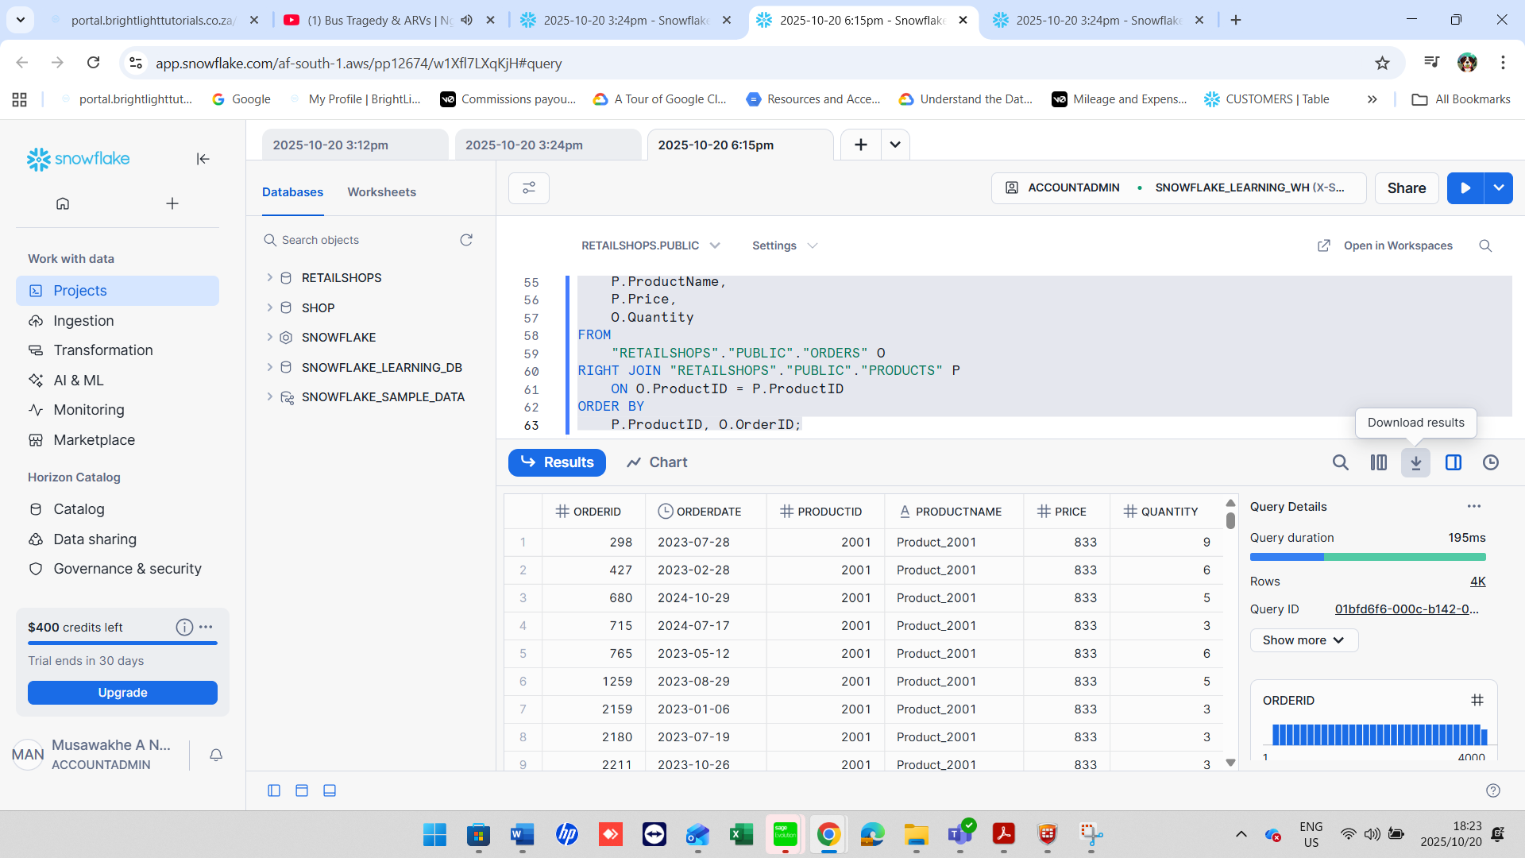

6. RIGHT JOIN: Customer Info with Orders (Include All Customers)
Question: Which customers have made orders, and include customers even if they have never placed an order.
Expected Output Columns:
- CustomerID, CustomerName, Country, OrderID, OrderDate, ProductID, Quantity
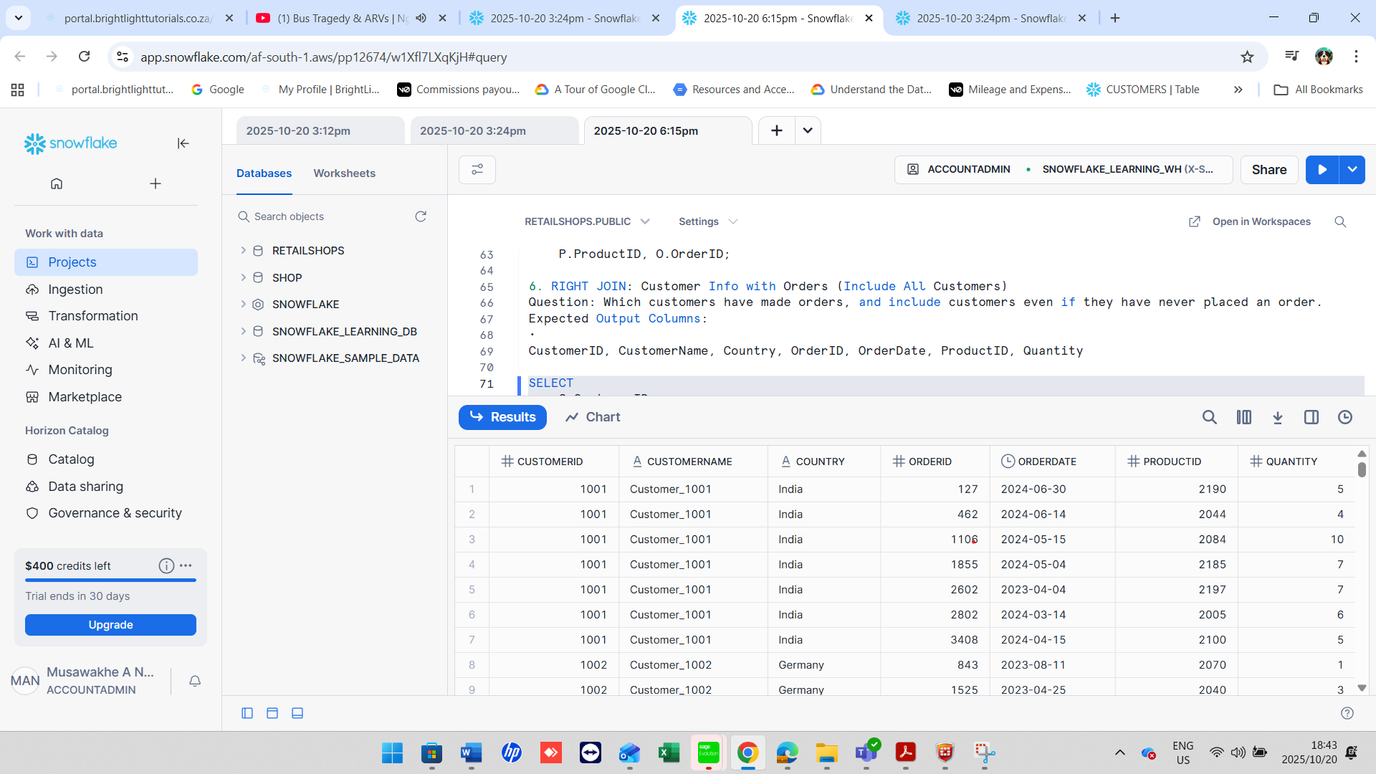

7. FULL OUTER JOIN: All Customers and All Orders
Question: List all customers and orders, showing NULLs where customers have not ordered or where orders have no customer info.
Expected Output Columns:
•CustomerID, CustomerName, Country, OrderID, OrderDate, ProductID, Quantity

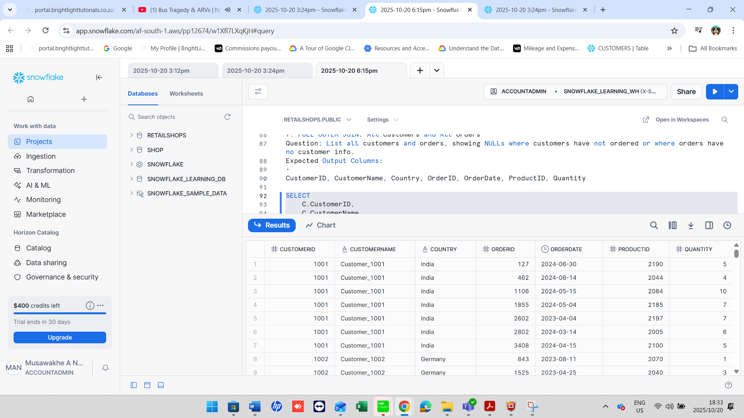
8. FULL OUTER JOIN: All Products and Orders
Question: List all products and orders, showing NULLs where products were never ordered or orders are missing product info.
Expected Output Columns:
- ProductID, ProductName, Price, OrderID, OrderDate, CustomerID, Quantity

